Segment Tree - Min

Problem
Build a segment tree with max build, query and update.

Example
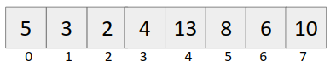

Structure
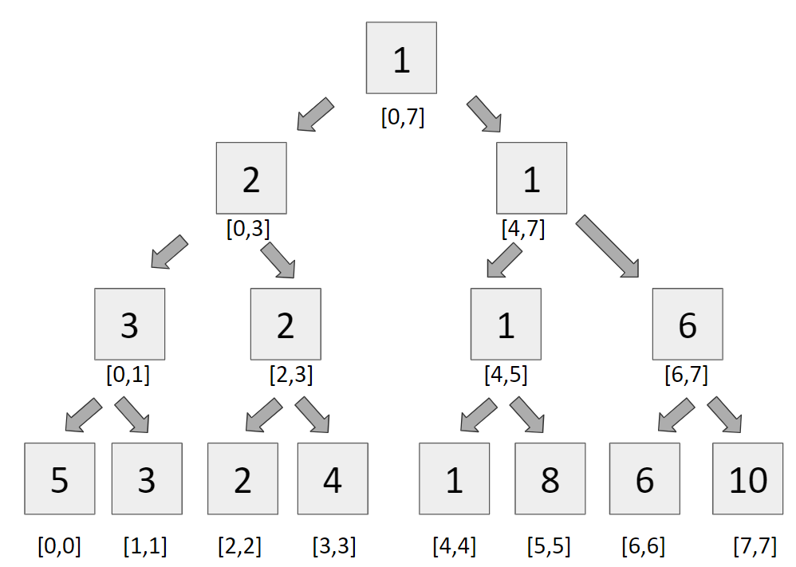

Approach
Building a segment tree
It is very simple to build a segment tree, we use divide and conquer approach to build the segment tree.

Query
For query, we see two types of segments
- Complete overlapping segments - When our st Partial overlapping segments and en lies completely in the range [l,r], it is called complete overlapping segment.
- Partial overlapping segments - When our st and en does not lie completely in the range [l,r], it is called partial overlapping segment.

Code
#include<bits/stdc++.h>
using namespace std;

#define int long long
#define endl "\n"
const int N = 1e5+2, MOD = 1e9+7;

int tree[4*N], a[N];

void build(int node, int st, int en){
if(st == en){
tree[node] = a[st];
return;
}

int mid = (st + en)/2;
build(2*node, st, mid);
build(2*node+1, mid+1, en);

tree[node] = min(tree[2*node], tree[2*node+1]);
}

int query(int node, int st, int en, int l, int r){
if(en < l || st > r){
return MOD;
}

if(l <= st && en <= r)
return tree[node];

int mid = (st + en)/2;
int q1 = query(2*node, st, mid, l, r);
int q2 = query(2*node+1, mid+1, en, l, r);

return min(q1, q2);
}

void update(int node, int st, int en, int idx, int val){
if(st == en){
a[st] = val;
tree[node] = val;
return;
}

int mid = (st+en)/2;
if(idx <= mid){
update(2*node, st, mid, idx, val);
}
else{
update(2*node+1, mid+1, en, idx, val);
}

tree[node] = min(tree[2*node], tree[2*node+1]);
}

signed main(){
int n,m;
cin >> n >> m;

for(int i=0; i<n; i++){
cin >> a[i];
}

build(1,0,n-1);

while(m--){
int type;
cin >> type;
if(type == 1){
int idx,val;
cin >> idx >> val;
update(1,0,n-1,idx,val);
}
else{
int l,r;
cin >> l >> r;
int ans = query(1,0,n-1,l,r-1);
cout << ans << endl;
}
}
return 0;
}

